The Visualization of the Atom

Abstract
Most atomic theory was formulated in the early part of the twentieth century. Since that time there have been a number of refinements. One aspect of the atom, however, was never resolved: the visual description of the atom. Because no one was able to accurately describe the atom in a viable and, at the same time, classical sense, it was ultimately dismissed as unsolvable or, more accurately, as a non-existent problem. This lack of “visualizeability” of the atom is challenged in the book The Visualization of the Atom by Helen A. Pawlowski. The book contends that there is a real or classical model that both complements and supplements the great body of mathematical information and early verbal descriptions pertaining to the atom. This visual pattern was discovered while re-examining an early form of the electron configuration chart based upon the Bohr model. Although this chart has since been supplanted in most textbooks by a newer wave configuration chart, both versions are still valid. By combining the horizontal readings of the old electron distribution chart to newly discovered facts (as read vertically on the same chart) a precise and workable order was discovered. This order also incorporated certain irregular electron movement (not distinguishing electrons movements) that heretofore had been ignored or merely classified as anomalies The next step was the transfer of these visual patterns first into a two-dimensional circular periodic table with a barrier bisecting the two halves, followed by a three-dimensional model of each of the atoms in which the barrier then became a polarity line. Each of the models, as they develop from the simple to complex, is built upon an underlying dipole structure, which is in harmony with the magnet-like characteristics of all atoms. As the circular table/model was built into a concrete and visualizeable form, it was observed that all eight chemical groups were in order, all valences were correct, and all ground state terms were in agreement. The final task was the collation and color-coding of the four quantum numbers onto the new circular model. In summary, the circular periodic table/model can be read as a periodic table, a three dimensional model with all chemical relationships intact, and/or it can also be color-coded to graphically illustrate quantum's four numbers.
1.0 Introduction
1.1 Problem: Although it is generally considered a closed issue by most scientists, the book entitled The Visualization of the Atom, reopens the old Einstein-Bohr debate concerning the lack of visualization in the description of the atom. But why be concerned about an argument that, at first glance, seems so irrelevant to a society that has outgrown the rudiments of atomic theory and is working on far more advanced problems?
1.2 Argument for Reopening the Issue: The author, Helen A. Pawlowski, claims that there are far too many anomalies being taught in the beginning classes of chemistry and physics as a result of this early failure to satisfactorily resolve this debate. In addition, considering the apathy often felt by students towards chemistry and physics, a visually oriented atom just might be the needed answer for injecting new life into both disciplines.
In addition, the new dipolar atom could also be a valuable tool to the seasoned, working scientists because of the graphically illustrated models of each individual atom.
1.3 The Motivator: Prior to linking-up with the Einstein-Bohr debate, the author first became interested in the sciences because of her concern with the standard periodic table. Foremost among her concerns was the fact that the lanthanide and actinide series (f series) were not included within the body of the table. Second, although each unit or square represented a single position for a specific element, the elements 57 lanthanum to 71 lutetium were lumped together in a single position. Third, the third transitionals (29, 30, 47, 48, 79, and 80) are classified in with the d block, while all advanced chemistry textbooks state that they really function as s elements. And last of all, the ground state terms verify that the third transitionals should
be in with the ²S_{½} or ¹S₀ elements, which are all representative elements.
1.4 Terms: Throughout the relatively short book (121 pages) the author has used the regular nomenclature for beginning chemistry and physics texts. There are, however, three terms that have been coined to describe the dipolar structure of the new table or model. They are the barrier of the periodic table, the polarity line of the circular model and the slider elements used in conjunction with the “aufbau” principle. In addition, there are four compound terms. They are words designed to join either a known concept to an unfamiliar concept (for example, orbital/quadrant) or a concept with a dual nature (for example, circular periodic table/model).
2.0 Review of Literature
2.1 The Problem Areas: Once it was determined that the periodic table had anomalies within it, the primary source to be examined was the electron distribution chart (earlier Bohr model in contrast to the wave). In addition to reading the chart in the usual horizontal manner, it was determined that there was also unique information to be had from the vertical reading of the same columns of numbers. Among the important facts to be considered were: (1) the location of the distinguishing electron movements in specific shells; (2) the number of electrons to be illustrated in a specific shell before moving to a shell farther-out or, in some cases, closer-in towards the nucleus; (3) the discovery that there were “irregular electron movements” which had not been incorporated into the earlier tables (or models). These were not the same as the aufbau movements of the distinguishing electrons as they build up the atoms from simple to complex. See Table 1.
2.2 The Electron Path around the Nucleus: Once the heretofore unrecognized vertical information was discovered, it became necessary to formulate a successful path for the electrons as they build up around the nucleus into eight distinct sectors. It
was discovered that a simple clockwise or anticlockwise path was not feasible. The reason being that hydrogen was in with the wrong chemical family. Eventually, a correct path was discovered in which the table was divided in half with a non-passable barrier running down the middle. The barrier resulted in a table reflecting a dipolar arrangement of the elements. On each shell, elements that were on the right side of the barrier were positive elements, those on the left side were negative elements or accept electrons when they are formed (as in the case of the inert gases). See Figure 1 of the correct path for main shells K, L, and M. This same path would also apply to the visual model of the atom.
Correct Path
Figure 1
2.2 The Electron Path around the Nucleus: Once the heretofore unrecognized vertical information was discovered, it became necessary to formulate a successful path for the electrons as they build up around the nucleus into eight distinct sectors. It

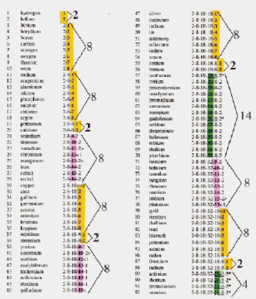
Electron Distribution Chart (Coded)
Table 1
2.3 The Sliders Are Revealed: Using seven concentric circles, with all but the inner circle divided into eight sectors (K or 1 has space only for a two-electron shell), the electrons were placed in each sector along the eight-radial spine if they were representative elements, and the remaining transitionals were placed in the space between the spine. In the process of visually observing the buildup, it was noted that due to the irregular electron movements, what had appeared to be a problem of “double seating” in the electron distribution chart of six sets of elements, no longer existed in the circular table/model. For example, look at the elements 55 cesium and 79 gold. Both of these elements have six main shells and their distinguishing electrons sit in position #1 of the outermost shell. Pauli's exclusion principle forbids such doubling up. Their configurations are as follows:
(55) 2 8 18 18 8 1

(79) 2 8 18 32 18 1
The answer to the dilemma lies in the fact that after the existence of cesium and before the formation of gold there is an irregular electron movement of an electron from the outermost shell to the second-from-the-last shell. This occurs after 78 platinum and before the formation of gold and thereby clears the position for the other element's distinguishing electron. The electron configurations of this area are as follows:
(78) | 2 | 8 | 18 | 32 | 17 | 1  
(79) | 2 | 8 | 18 | 32 | 18 | 1

Electrons that either move, due to the irregular electron movements, or replace a vacated position are called “sliders” in the circular periodic table/model.
2.4 Electrons Fit in Sectors: With the reading of the electron distribution chart vertically as well
as horizontally in relationship to a dipolar path, along with an understanding of the function of the “slider” electrons, it was a relatively simple task to put the table together. All valences, families and ground states are in harmony with the known atomic facts. See Figure 2.
The Circular Periodic Table/Model
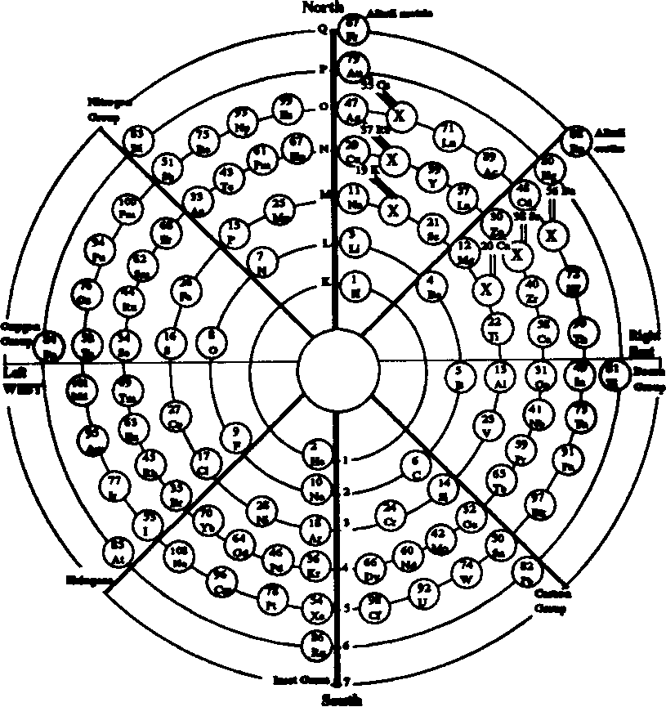
© 1990 by Helen A. Pawlowski
Figure 2
2.5 Advantages of the Circular Table/Model: Close to a dozen “advantages” are listed in chapter three. Some of them are as follows: (1) Increased aesthetics due to the fact that the f series are within the body of the table/model, as well as the almost even distribution of the transitionals within the eight sectors. (2) The electron count per each main-shell is in harmony with atomic theory. (3) The silhouettes of the inert gases reveal the eight “nirvana-like” patterns in addition to available electron space starting with 18 argon. (4) There is a graphically improved concept of valence determination in the representative elements. (5) There is an explanation of why all transitionals are positive in their nature even though they are on both sides of the model's polarity line. (6) An explanation is given concerning the qualities of negativeness, neutrality, or positiveness as indicated in such elements
as 9 fluorine (negative), 10 neon (neutral), and 11 sodium (positive). (7) There is comparison of a tight verbal description of the inner structure of the atom (found in an international encyclopedia) to the new circular model of the atom. (8) And finally, an explanation is given of the incorrectness of placing the third transitionals (29, 30, 47, 48, 79, and 80) in the d block of the standard periodic table instead of the s block.
2.8 The Need to Tie-In with Quantum: The first attempt to promote the book in August of
of 1987 met with only partial success. Although many found the model of the atom most interesting, they were deeply concerned that it had not been collated to the basic tenets of quantum. In cooperation with other individuals, the four quantum numbers have now been color-coded onto the circular model. Everything fits quite comfortably.
2.9 Quantum One and the Circular Model: The principle number or quantum one required no special collating effort. To read quantum one on the circular model, one merely chooses an element anywhere on the model and then follows the concentric “shell” line to the polarity line in the center where the 1 to 7 designations are found. These numbers can then be translated into the principle number that describes the bulk of the manifested energy.
2.6 The Circular Table/Model and Physics: Several relatively new concepts are incorporated into the new model of the atom. First, it was necessary that atoms manifest magnet-like characteristics because of the polarity line in the circular model. This is now acknowledged by the leading physicists to be the case—atoms are indeed magnets. Second, it was necessary that electrons are described in terms of standing waves and that, as such, they do not “orbit” around the nucleus as previously believed. These two concepts are an integral part of the new model and are likewise stated as such by leading scientists.
2.7 The Anomalies of Physics Are Explained: Although not developed in minute detail, reference is made in the book to the fact that there are two extra two electrons in the alkali metals and alkali earths of the circular model. Early in the development of the atomic theory, Pieter Zeeman discovered “extra spectral lines” in the area of the alkali metals and alkali earths when subjected to a magnet. This phenomenon is called the Anomalous Zeemen Effect. The circular model vindicates an increase of spectra lines in families I and II. Physics textbooks often mention the “Hund’s half-filled shell” phenomenon. Again, the circular model requires a dipolar model in which such phrases as “less-than-half-filled shell” or “more-than-half-filled shell” fit quite comfortably. The circular model's electrons fill first the right side of the polarity line in the positive field and then the left side of the polarity line in the negative field.
2.10 Reading Quantum Two: Before it became possible to color-code the circular model for quantum number two, it was necessary to determine how the atom was being subdivided according to (1) main shell, (2) subshell, and (3) orbital. It was also necessary to understand that quantum two is a phenomenon related to the relative intensity of an electron as it sits among other electrons in a particular main shell, that is, the azimuthal values of s, p, d, and f.

The s subshell on any given main shell is believed to be on the identical shell as the p electrons, but the two have different intensities or energy values. The s subshell will have an electron count of two electrons per subshell, while the p electrons will consist of six electrons per subshell.

The d series or azimuthal values are also made visual on the circular model. Each of the d series consists of ten electrons all on the same main shell. The first member of the first d series is the transitional 21 scandium. (It should be noted that all transitionals are filling-in the interior of the atom, either on the second-from-the-last shell [d series] or the third-from-the-last shell [f series].) After the placement of the first eight electrons in the eight sectors between the spine, where do the extra two electrons come from to bring the count to the
a new periodic table became a three dimensional model of each of the elements from 1 hydrogen to 102 nobelium. This model was then collated to the data pertaining to quantum one, two, three, and four.

The books covers such subjects as: (1) the great quantum debate between Einstein and Bohr concerning the lack of a classical, visual atom; (2) the anomalies of the standard periodic table, which includes the f series not included within the body of the table and the wrongful placement of certain elements in the d block instead of the s block; (3) the conversion of the table into a three-dimensional model in which every electron is accounted for and in the right place as set forth in the electron distribution chart; (4) various unexplained anomalies in physics are given a fresh interpretation as viewed from the point of view of the new circular table/ model; (5) all four quantum numbers are collated onto the circular model—this being done without disturbing the electron count per orbital or the number of orbitals per subshell.
2.11 Quantum Three and Four: Both of these are also coded onto the circular periodic table/model. Third quantum refers to the angular magnetic moment (or movement) that occurs when comparing any two electrons of a given orbital on a given subshell. Quantum four is the spin up or spin down of the electrons. In the circular model the spin up or spin down (whole or half integers) is also color-coded for ease in reading.
2.12 The Wave Electron Configurations: With the coding of the four quantum numbers (s, p, d, and f) to the circular periodic table/model, it became possible to also read the wave configurations from the new table or model.
3.0 Conclusions
3.1 In conclusion, what started out to be merely
required ten? The answer, of course, is the irregular electron movement as mentioned earlier (2.1). These two additional electrons that have dropped down into the second-from-the-last shell bring the count of electrons in the d series to ten.

The f series commences with 57 lanthanide. There must be 14 electrons all on the same subshell, which incidentally, just happens to be on the third-from-the-last shell. Placing the first eight electrons into the eight sectors between the spines presented no problems. But where do the other six electrons come from? Again, staying on the same subshell of the same main shell, we find that the first two sectors or families (I and II) are completely filled up, whereas the other families III to VIII still have one vacant spot. (Note: This difference was caused by the fact that the alkali metals and alkali earths or families I and II both were carrying an extra electron as mentioned earlier [2.7].) So, with the first two sectors filled to capacity, the next distinguishing electrons seats itself in groups III to VIII of which there are six positions available. Eight and six electrons in the same subshell on the same main shell bring the total of electrons to fourteen. The exact number required for the f series.

